**JEIS2002 General Arrangement Technical Appendix 2025**

**Name and Student Number:**

**Yang Zhou 2022282104(HEU) 34463801(UOS)**

**Techno-Economic Study**

**Table 1: Base Calculations**

|  |  |  |  |  |  |
| --- | --- | --- | --- | --- | --- |
| Speed, V [kts] | Voyage Days | Loading Days | Total Voyage Days | Voyages per Year | Sea Days per Year |
| 15 | 16.6666667 | 1.8 | 18.46666667 | 18.95 | 315.88 |
| 16 | 15.625 | 1.8 | 17.425 | 20.08 | 313.85 |
| 17 | 14.7058824 | 1.8 | 16.50588235 | 21.20 | 311.83 |

图表, 折线图

AI 生成的内容可能不正确。

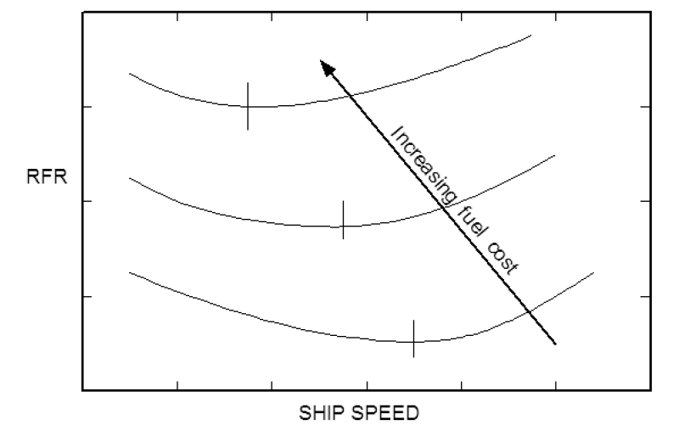

**Figure 1: Influence on RFR of varying ship speed and fuel costs**

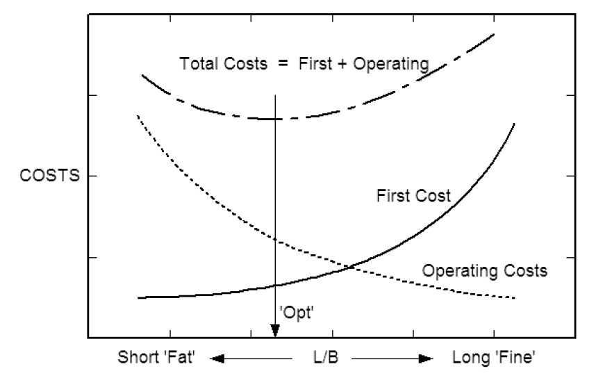图表, 折线图

AI 生成的内容可能不正确。

**Figure 2: Influence of L/B on ship costs.**

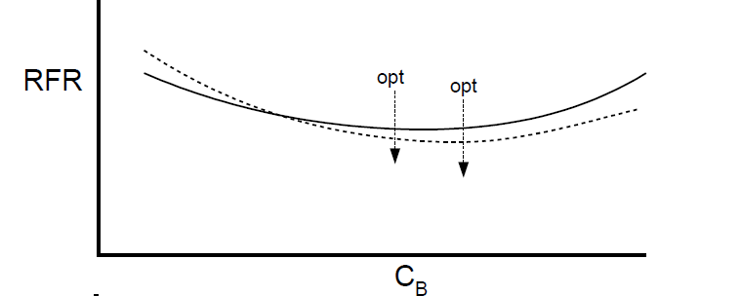

图表, 折线图

AI 生成的内容可能不正确。

**Figure 3: Required Freight Rate against CB**

图表, 折线图

AI 生成的内容可能不正确。

**Table 2: Ship Dimensions**

|  |  |  |  |
| --- | --- | --- | --- |
|  | ShipDes | Maxsurf | % Difference |
| LBP [m] | 135.4 | 137.785 | 1.730957651 |
| B mld [m] | 20.83 | 20.774 | -0.269567729 |
| D mld [m] | 12.92 | 13.08 | 1.22324159 |
| D mid deck [m] | 7.5 | 7.5 | 0 |
| T (load) [m] | 9.05 | 9.050 | 0 |
| CB (load) | 0.653 | 0.653 | 0 |
| Displacement [tonnes] | 17074 | 17185 | 0.645912133 |
| Cargo DW[tonnes] | 10500 |  |  |
| Total DW[tonnes] | 11749 |  |  |
| Machinery Mass [tonnes] | 726 |  |  |
| Outfit Mass [tonnes] | 1156 |  |  |
| Steel Mass [tonnes] | 3338 |  |  |
| Lightship Mass [tonnes] | 5325 |  |  |
| (Cw)f  at depth D1 |  | 0.788 |  |
| Service Speed [knots] | 17 |  |  |
| Endurance [nm] | 12000 |  |  |
| Range [nm] | 6000 |  |  |
| Installed Power [kW] | 7116 |  |  |
| Service Power [kW] | 5474 |  |  |

**APPENDIX A – Techno-Economics**

**Table 3: Required Freight Rates for a range of ship speeds and fuel prices**

|  |  |  |  |
| --- | --- | --- | --- |
| **Speed** | **£40/Tonne** | **£55/Tonne** | **£70/Tonne** |
| **15** | **11.00** | **11.47** | **11.94** |
| **16** | **10.94** | **11.46** | **11.97** |
| **17** | **10.91** | **11.46** | **12.02** |

**Table 4: Ship costs for a range of L/B ratios.**

|  |  |  |  |
| --- | --- | --- | --- |
| **L/B** | **AAC** | **AFC** | **Total Cost** |
| **5.5** | **651194.97** | **350446.66** | **1001641.6** |
| **6.0** | **650129.66** | **334629.99** | **984759.65** |
| **6.5** | **655073.67** | **329631.26** | **984704.93** |
| **7.0** | **664567.42** | **332738.99** | **997306.41** |

**Table 5: Required freight rates for a range of CB values at the optimum L/B ratio.**

|  |  |
| --- | --- |
| **CB** | **RFR** |
| **0.60** | 11.18 |
| **0.65** | 10.91 |
| **0.70** | 11.47 |
| **0.75** | 14.09 |
| **0.80** | Out of range |
| **0.85** | Out of range |

**APPENDIX B – Floodable Length Curve (Please plot graph rather than use screenshot)**



**APPENDIX C – EEDI**

**Table C1: Main and Auxiliary Engine Data**

|  |  |
| --- | --- |
| **Installed Power MPP [kW]** | **6990** |
| **PME [kW]** | **5242.5** |
| **PAE [kW]** | **262.125** |
| **SFC ME [g/KWh]** | **171** |
| **SFC AE [g/KWh]** | **215** |
| **CF HFO** | **3.114** |
| **CF DO** | **3.206** |
| **Ship Design Speed [knots]** | **16** |

**Table C2: Deadweight components**

|  |  |
| --- | --- |
| Cargo DWT | **10500** |
| OF [t] | **950** |
| DO [t] | **150** |
| LO [t] | **50** |
| FW [t] | **200** |
| Stores [t] | **100** |
| Crew/PX/Sundries [t] | **50** |
| Swimming Pool Water [t] | **43.4** |
| **Total DWT** | **12043.4** |

**Table C3: EEDI values**

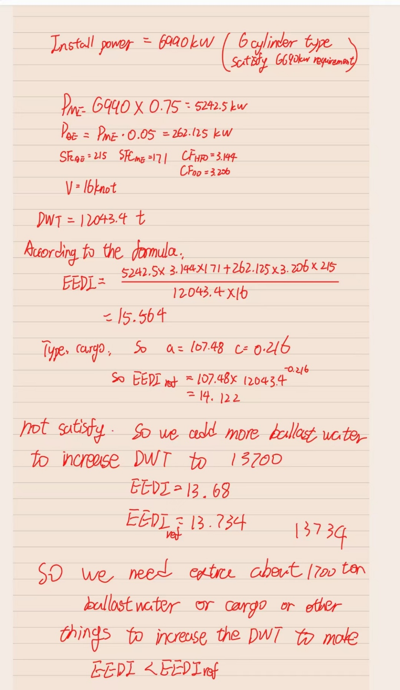

|  |  |
| --- | --- |
| **EEDI [g/t-nm]** | **13.68** |
| **Reference EEDI [g/t-nm]** | **13.734** |

**APPENDIX D – Tonnage**

**Table D1: Ship volumes**

|  |  |
| --- | --- |
| **Underdeck Volume [m3]** | **19181.015** |
| **Forecastle volume [m3]** | **1166.956** |
| **Superstructure volume Deck1 [m3]** | 1168.75 |
| **Superstructure volume Deck2 [m3]** | 1111.15 |
| **Superstructure volume Deck3 [m3]** | **894.1** |
| **Superstructure volume Deck4 [m3]** | 772.9 |
| **Superstructure volume Deck5 [m3]** | 580.75 |
| **Total Superstructure volume [m3]** | **4527.65** |

**Table D2: Values used in tonnage calcs**

**K1 = 0.2 + 0.02 log10V**

***K2* = 0.2 + 0.02 log10 *Vc***

|  |  |
| --- | --- |
|  | **0.3079** |
|  | **24875.621** |
|  | **0.30623** |
|  | **20499.621** |
|  | **0.97222** |
|  | **1.25** |
|  | **46** |
|  | **0** |

**Table D3: Tonnage Values**

|  |  |
| --- | --- |
| **GT** | **7659.588** |
| **NT** | **5990.91** |

**APPENDIX E – Freeboard**

|  |  |
| --- | --- |
| Ship Type | B |
| Tabular Freeboard [mm] | 1979 |
| Correction to the freeboard for ships under 100 m in length | 0 |
| Correction for block coefficient | 1.032 |
| Correction for depth | 766.75 |
| Correction for position of deck line | 0 |
| Correction for recess in freeboard deck | 0 |
| Correction for Superstructure and Trunks | -328.49 |
| Correction for Sheer | 356.3 |
| **Minimum Summer freeboard [mm]** | 2836.888 |
| **Minimum Bow Height [mm]** | 5806.74 |

|  |  |
| --- | --- |
| **[m]** | 10.2 |
|  | 0.724 |
|  | 0.768 |
| **Width of Superstructure [m]** | 18 |
| **Length of Superstructure on main deck [m]** | 26.6 |
| **Forecastle height [m]** | 2.63 |
| **Forecastle length [m]** | 27.3 |
| **Effective Superstructure Length [m]** | 53.2 |

|  |  |  |  |  |  |  |  |  |  |  |
| --- | --- | --- | --- | --- | --- | --- | --- | --- | --- | --- |
| **Station** | Factor | Ideal | Actual | Ideal  *Factor | Actual  *factor | Ideal | Actual | Deficit | Average | Sheer Corr |
| AP | 1 | 1366.67 | 0 | 1366.67 | 0 | 3646.22 | 0 | 455.78 | 549.73 | 356.3 |
| 1/6L from AP | 3 | 606.8 | 0 | 1820.34 | 0 |
| 1/3L from AP | 3 | 153.07 | 0 | 459.21 | 0 |
| Amidships | 1 | 0 | 0 | 0 | 0 |
| Amidships | 1 | 0 | 0 | 0 | 0 | 7292.52 | 1423.09 | 733.68 |
| 1/3L from FP | 3 | 306.133 | 0 | 918.39 | 0 |
| 1/6L from FP | 3 | 1213.6 | 141.03 | 3640.8 | 423.09 |
| FP | 1 | 2733.33 | 1000 | 2733.33 | 1000 |

**APPENDIX F – General Arrangement Results (Engine Room Length, Capacities, Water ballast CG)**

**Figure F1: Plot of Engine Room Length against Power**

|  |
| --- |
| Code generated image |

**Figure F2: Engine Layout Diagram showing required power.**

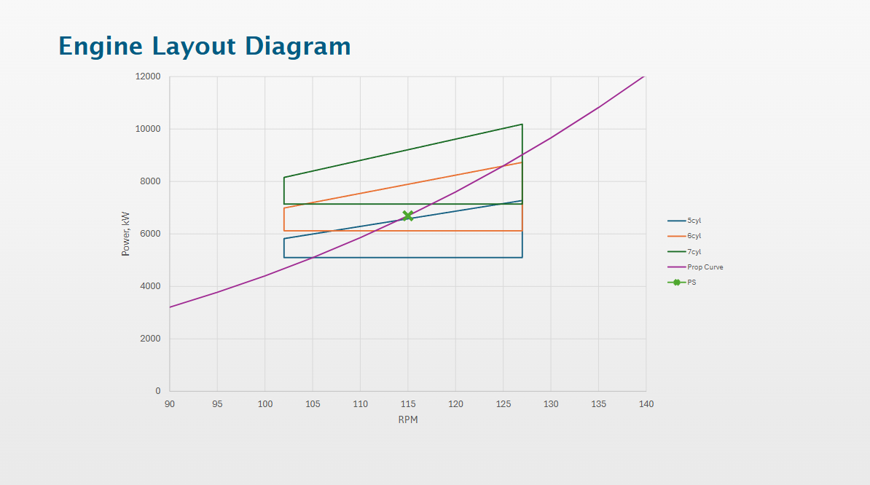

**Table F0 – Frame spacing**

|  |  |  |  |  |
| --- | --- | --- | --- | --- |
|  |  |  |  |  |
| Ship length | Lloyds req. frame spacing (m) | Chosen frame spacing -l (m) | Number of frames - n at spacing - l | n x l |
| FP to .05L | 0.6 | 0.6 | 12.0000 | 7.2 |
| .05L to .2 L from FP | 0.693 | 0.6 | 32 | 19.2 |
| .2L to .25L from FP | 0.0733 | 0.7 | 10 | 7 |
| .25L from FP to .15L from AP | 0.0733 | 0.7 | 115 | 80.5 |
| .15L to .05L from AP | 0.733 | 0.7 | 19 | 13.3 |
| .05L to AP | 0.6 | 0.6 | 12 | 7.2 |
|  |  |  | TOTAL | 134.4 |

**Table F1: Bulkheads**

|  |  |
| --- | --- |
| **Name** | **Location** |
| 1 | -63.200 |
| 2 | -45.500 |
| 3 | -29.400 |
| 4 | -18.900 |
| 5 | 5.600 |
| 6 | 38.500 |
| 7 | 58.600 |

**Table F2: Room Definitions**

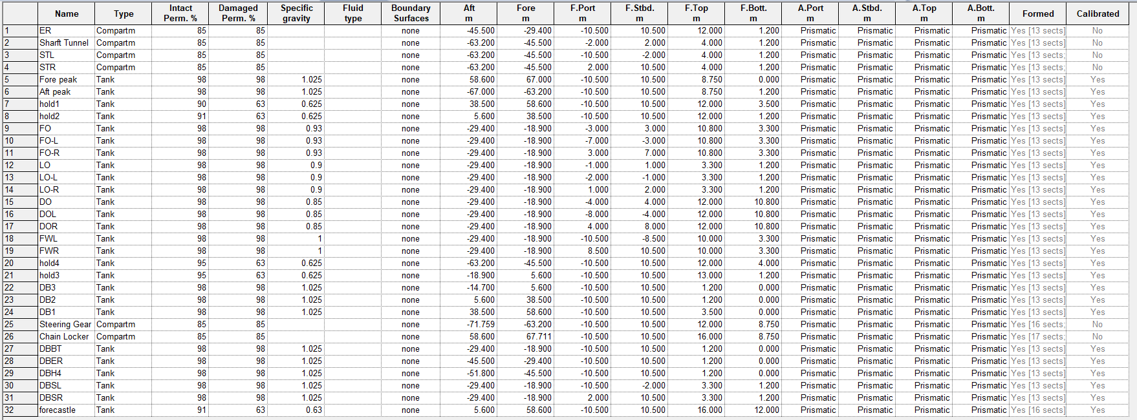

**Table F3: Fluid Volumes**

|  |  |  |  |  |  |
| --- | --- | --- | --- | --- | --- |
| **Name** | **Total Mass** | **Total** | **Long. Arm** | **Trans. Arm** | **Vert.** |
|  | **tonne** | **Vol.** | **m** | **m** | **Arm** |
|  |  | **m^3** |  |  | **m** |
| Fore peak | 134.857 | 131.568 | 61.135 | 0 | 5.745 |
| DB1 | 539.083 | 525.935 | 46.007 | 0 | 2.036 |
| DB2 | 609.712 | 594.841 | 20.905 | 0 | 0.667 |
| DB3 | 409.663 | 399.671 | -4.442 | 0 | 0.666 |
| Aft Tank | 24.525 | 23.927 | -63.52 | 0 | 1.2 |
| **Total Fixed** | **1717.84** | **1675.942** | 24.675 | 0.000 | 1.595 |
| DBBT | 168.619 | 164.506 | -23.894 | 0 | 0.674 |
| DBER | 152.532 | 148.811 | -36.309 | 0 | 0.689 |
| DBH4 | 27.941 | 27.259 | -48.37 | 0 | 0.713 |
| DBSR | 157.704 | 153.857 | -23.97 | 5.586 | 2.286 |
| DBSL | 157.704 | 153.857 | -23.97 | -5.586 | 2.286 |
| **Total Trimming** | **664.5** | **648.29** | -27.809 | 0.000 | 1.444 |
| FO | 430.637 | 463.05 | -24.15 | 0 | 7.05 |
| FO-L | 287.091 | 308.7 | -24.15 | -5 | 7.05 |
| FO-R | 287.091 | 308.7 | -24.15 | 5 | 7.05 |
| **Total FO** | **1004.819** | **1080.45** | -24.150 | 0.000 | 7.050 |
| DO | 83.966 | 98.784 | -24.15 | 0 | 11.4 |
| DOL | 41.983 | 49.392 | -24.15 | -6 | 11.4 |
| DOR | 41.983 | 49.392 | -24.15 | 6 | 11.4 |
| **Total DO** | **167.932** | **197.568** | -24.150 | 0.000 | 11.400 |
| LO | 38.896 | 43.218 | -24.15 | 0 | 2.25 |
| LO-L | 19.448 | 21.609 | -24.15 | -1.5 | 2.25 |
| LO-R | 19.448 | 21.609 | -24.15 | 1.5 | 2.25 |
| **Total LO** | **77.792** | **86.436** | -24.150 | 0.000 | 2.250 |
| FWL | 122.957 | 122.957 | -23.92 | -9.411 | 6.857 |
| FWR | 122.957 | 122.957 | -23.92 | 9.411 | 6.857 |
| **Total FW** | **245.914** | **245.914** | -23.929 | 0.000 | 6.857 |

**1500T ballast water CG in 25.9m**

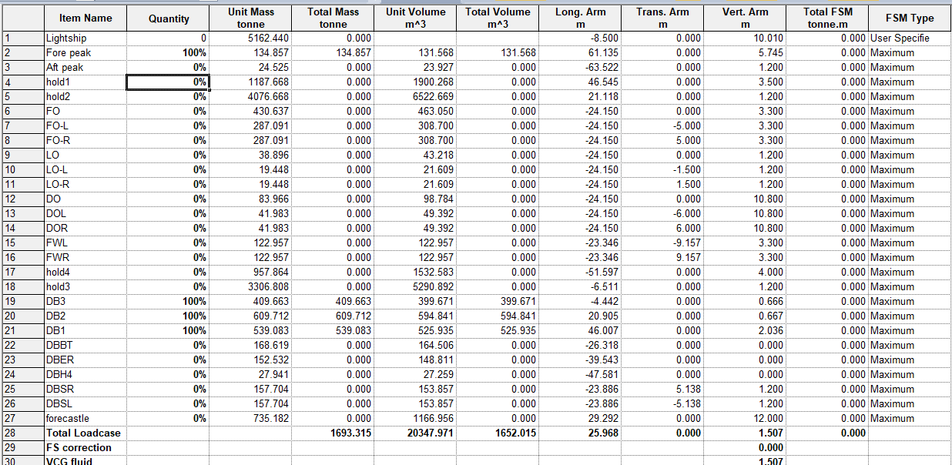

**Table F4: Cargo Capacity**

|  |  |  |  |  |  |
| --- | --- | --- | --- | --- | --- |
| **Name** | **Total Mass tonne** | **Total Vol. m^3** | **Long. Arm m** | **Trans. Arm m** | **Vert. Arm m** |
| Hold 1 | 1187.668 | 1900.268 | 46.938 | 0 | 7.942 |
| Hold 2 | 4076.668 | 6522.669 | 21.628 | 0 | 6.666 |
| Hold 3 | 3306.808 | 5290.892 | -6.622 | 0 | 6.675 |
| Hold 4 | 957.864 | 1532.583 | -52.87 | 0 | 8.715 |
| Forecastle | 735.182 | 1166.956 | 41.836 | 0 | 13.207 |
| **Total Cargo** | **10264.19** | **16413.368** | 9.950 | 0.000 | 7.476 |

**NEED (10500-0.9*10264.19)/12 =106 CONTAINER in the deck**

**APPENDIX G Intact and Damage Stability**

**Lightship VCG and LCG**

Table G1 – Lightship Loadcase (including CoGs)

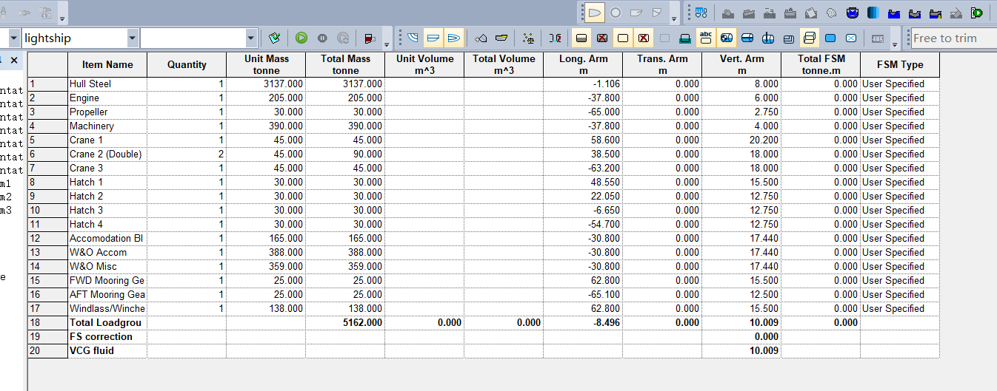

**Load cases (Full load and Ballast) – Hydrostatics (inc Trim)**

Table G2 – Full Load Loadcase (including CoGs)

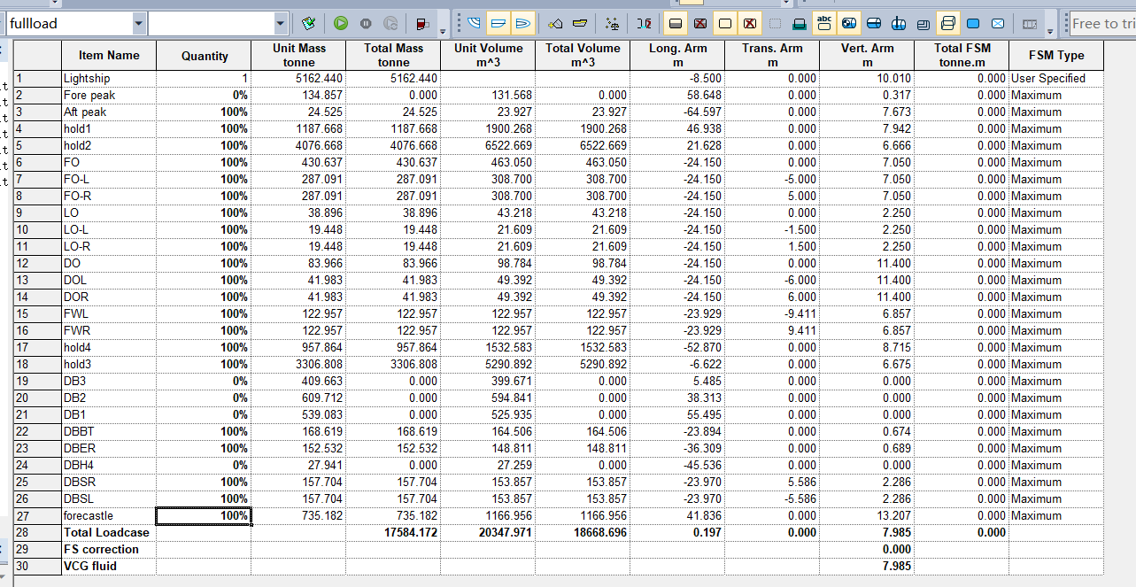

Table G3 – Ballast Loadcase (including CoGs)

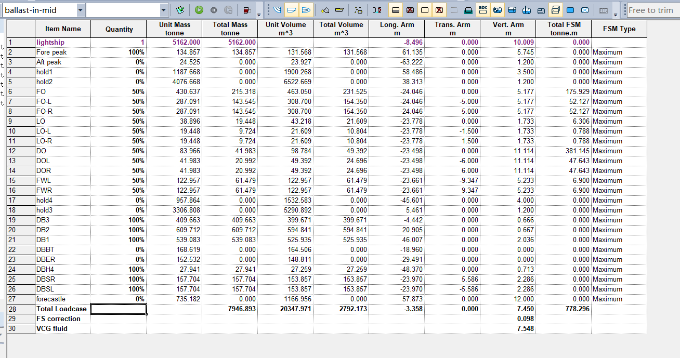

Table G4 – Equilibrium draught and trim for Full load and Ballast loadcases (with comments if unable to meet requirements)

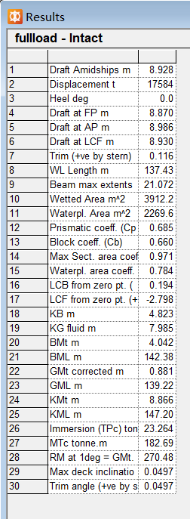**电脑屏幕的照片

AI 生成的内容可能不正确。**

**GZ curve (intact)**

Table G5 – Large Angle Stability in Full Load against IMO criteria.

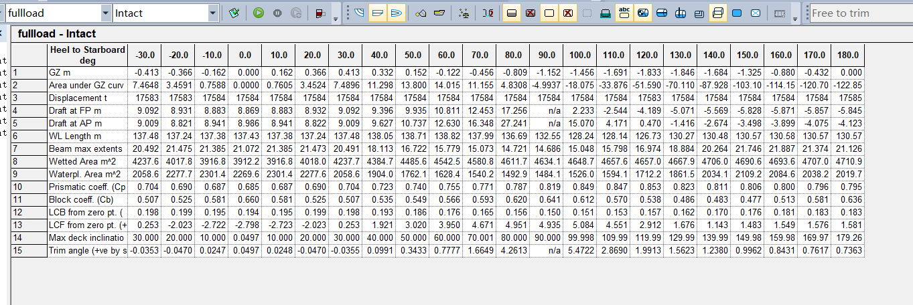

Figure G1 – GZ curve for full load



**Probabilistic Damage Results**

Table G6 – Damage Stability Results for Full Load (with comments if failed to meet requirements)

图形用户界面, 应用程序, 表格, Excel

AI 生成的内容可能不正确。